
Department of Computer Science and Engineering DevOps Lab - L3

Lab Assignment No: 9
Name of Student | Atharva Rale
PRN | 23070122174
Batch | 2023 – 2027
Class | CSE – B1
Academic Year & Semester | 2026 - 2027, 7th Semester
Title of Assignment | Container Management & Networking
Implementation & Theory | Run container detached — Started a new container from the my-flask-app image in detached mode (-d) with port mapping 8080:5000, returning the container ID.  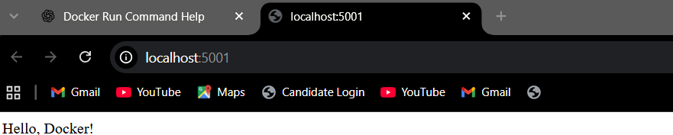  Access via browser — Verified the app was reachable at http://localhost:5001, displaying "Hello, Docker!"

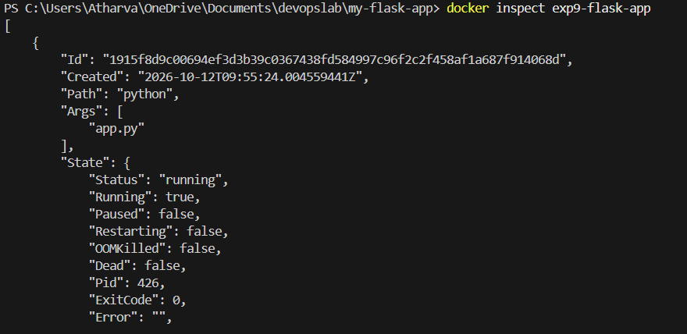
List running containers — docker ps showed the container's status as "Up," with the port mapping 0.0.0.0:5001->5000/tcp confirmed.
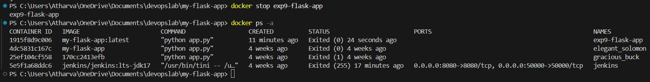

Stop the container — Used docker stop with the container ID/name; Docker returned the same identifier once stopped.

Running vs. all containers — docker ps returned an empty list (no running containers), while docker ps -a showed the container still present with status "Exited," confirming stopped containers persist until explicitly removed.
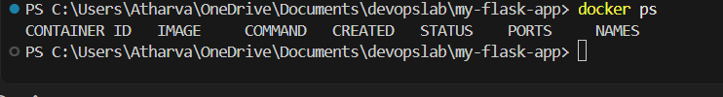
Inspect network settings — docker inspect on the stopped container revealed the NetworkSettings block, including its internal IP address, gateway, and configured port bindings.

Remove the container — docker rm deleted the stopped container; a follow-up docker ps -a confirmed it no longer appears in the container list.

